UART Transmitter (UART TX) Design & Verification Report

Student: Huda Saad Fawzi Al-Qaey

Introduction to UART
UART stands for Universal Asynchronous Receiver-Transmitter. It is a fundamental hardware communication protocol used for serial data transmission between digital systems. Unlike synchronous protocols, UART is asynchronous, meaning it does not rely on a shared clock signal between the transmitter and receiver. Instead, data is transmitted bit-by-bit sequentially over a single physical line, packaged inside standard frames that include a Start Bit(0), payload data bits, an optional Parity Bit for error detection, and a Stop Bit(1).

System Architecture & Top-Level Module (UART_TX)
The overall design is centered around the primary module UART_TX which serves as the top-level wrapper integrating four core sub-modules:
1. Finite State Machine (FSM) Control Unit: Manages state transitions, handshaking, and routing logic.
2. Serializer (PISO): Transforms parallel data into a serial bitstream.
3. Parity Calculator: Computes even or odd parity over the data payload.
4. Multiplexer (MUX): Directs the correct signal channel onto the primary output line (TX_OUTPUT).
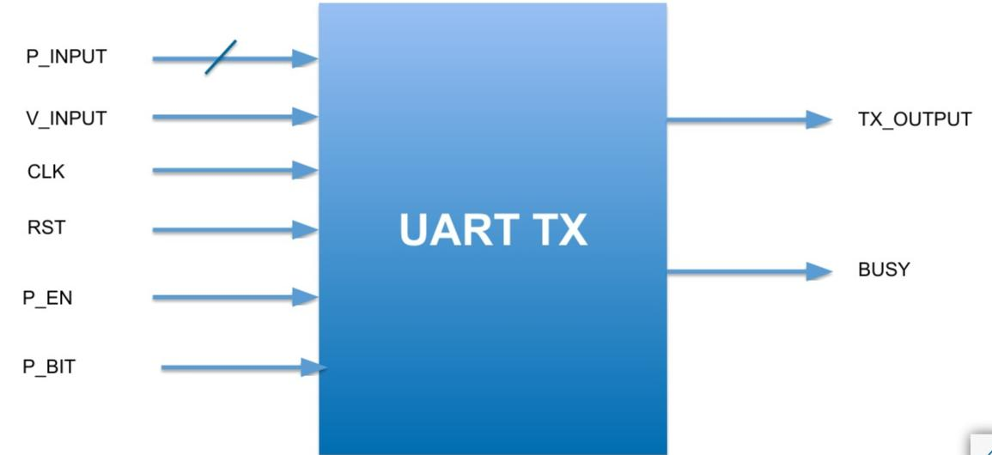

Interface Signal Definitions:
- P_INPUT: Parallel data input vector to be serialized.
- V_INPUT : Valid input strobe triggering frame transmission.
- CLK/ RST : Main system clock and active-high/low reset line.
- P_EN : Parity Enable control bit (1): Enable parity bit, (0): Bypass parity.
- P_BIT: Parity Type selector (0: Even parity, 1: Odd parity).
- TX_OUTPUT : Physical serial output line driving transmitted data.
- BUSY : System status flag asserting high during active frame transmission.
Design Parameterization & Scalability :
- The top-level design and underlying sub-modules utilize Verilog parameterization (parameter DATA_WIDTH = 8).
- While configured for an 8-bit bus payload by default, the codebase is fully scalable. Adjusting DATA_WIDTH ( from 8 to 16 bits) automatically updates the internal shift registers, counter dynamics, and FSM terminal counts across all modules without modifying the underlying architecture.

RTL Sub-Modules Architecture & Detailed RTL Design
Finite State Machine (FSM) Control Unit:
- Architecture & State Encoding: Implemented as a Moore/Mealy hybrid FSM managing five discrete operational states: IDLE (3’b000), START (3’b001), SER_DATA (3’b010), PARITY (3’b011), and STOP (3’b100).
- State Transitions & Handshaking: In IDLE, the FSM monitors V_INPUT. Upon detecting V_INPUT = 1, it immediately asserts BUSY = 1, transitions to START, and generates a load pulse to latch parallel datainto the Serializer. After driving the Start bit, it advances to SER_DATA and asserts ser_en = 1.
- Dynamic Path Execution:The FSM continuously samples ser_done from the Serializer. Once ser_done = 1, it checks P_EN. If P_EN = 1, it transitions to PARITY for one clock cycle; if P_EN = 0, it bypasses PARITY directly to STOP . Finally, it drives the Stop bit, de-asserts `BUSY = 0`, and returns to IDLE.
- Control Outputs:Generates the 2-bit routing signal mux_sel (2’b00: Start, 2’b01: Data, 2’b10: Parity, 2’b11: Stop/Idle) to control the top-level multiplexer output.

Parallel-In Serial-Out (PISO) Serializer Module:
- Internal Architecture: Built around an internal shift register sized to DATA_WIDTH and an internal bit-counter log2(DATA_WIDTH)
- Data Latching & Shifting:When load = 1 is asserted by the FSM, P_INPUT is synchronously latched into the internal register. Upon ser_en = 1, data shifts out LSB-first (P_INPUT[0] to P_INPUT[DATA_WIDTH-1]), driven by nposedge CLK.
- Termination Signaling:The internal counter increments on every active clock edge during ser_en. Upon reaching state DATA_WIDTH – 1 (3’b111 for 8 bits), the module asserts ser_done = 1 to notify the FSM that serialization is complete.

Parity Calculator Module:
- Combinational Logic: Computes parity dynamically over P_INPUT using XOR reduction logic (^P_INPUT).
- Mode Selection (P_BIT):Supports Even Parity (P_BIT = 0, parity out 1 if the number of 1s is odd) and Odd Parity (P_BIT = 1, parity out 1 if the number of 1s is even).
- Gating:Computations run combinationally, but the output is routed to TX_OUTPUT strictly when selected by mux_sel = 2’b10.
Top-Level Multiplexer (MUX) Module:
- Routing Logic:A 4-to-1 combinational multiplexer selecting TX_OUTPUT. based on mux_sel driven by the FSM:
2’b00: Routes logic LOW (1’b0 ) for Start Bit.
2’b01: Routes ser_data_out from Serializer for Payload Data .
2’b10: Routes parity_out from Parity Calculator for Parity Bit .
2’b11: Routes logic HIGH (1’b1) for Stop Bit / Idle State .
Testbench Implementation, Verification Methodology and Debugging Journey
To ensure complete verification coverage, the system was evaluated using top-level testbench simulations, followed by sub-module isolation tests, and finally targeted debugging iterations on delay controls.
Phase 1: Initial Top-Level Testing and Waveform Analysis
Top-level verification began using the master testbench (UART_TB.v) to sample output signals on TX_OUTPUT.
Transcript Baseline: In the initial baseline run, all payload data bits (DATA_BIT_0 through DATA_BIT_7), and the Stop Bit achieved PASS status in the script transcript. However, the Start Bit reported a FAIL in the transcript script (specifically during the second frame transmission with parity enabled).
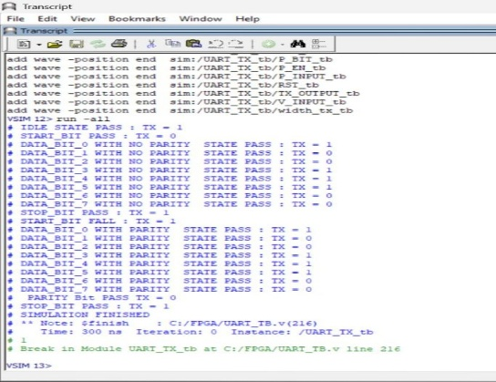
Visual inspection of ModelSim waveforms was conducted to compare physical signal transitions against the transcript output.
Detailed Waveform Inspection Breakdown:
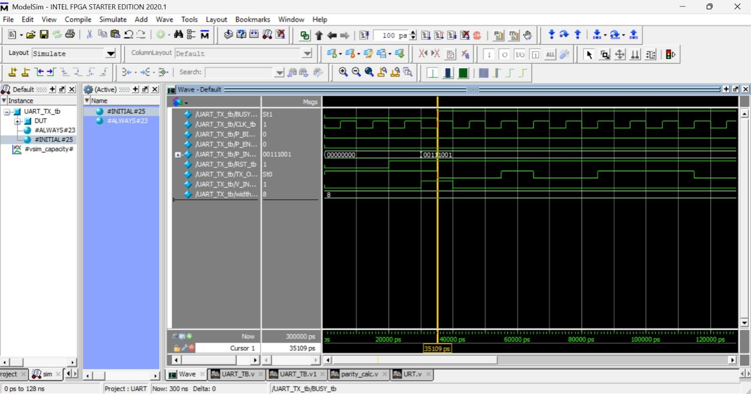
Start Bit Case (First posedge CLK): When V_INPUT = 1 and BUSY = 1, the system enters the Start bit condition. The waveform shows TX_OUTPUT = 0, matching expected hardware logic.

Data Bit Case (Data Bit 0): When V_INPUT = 0 and BUSY = 1, the system transitions into serial transmission, and TX_OUTPUT correctly displays the payload data starting at DATA_BIT_0.
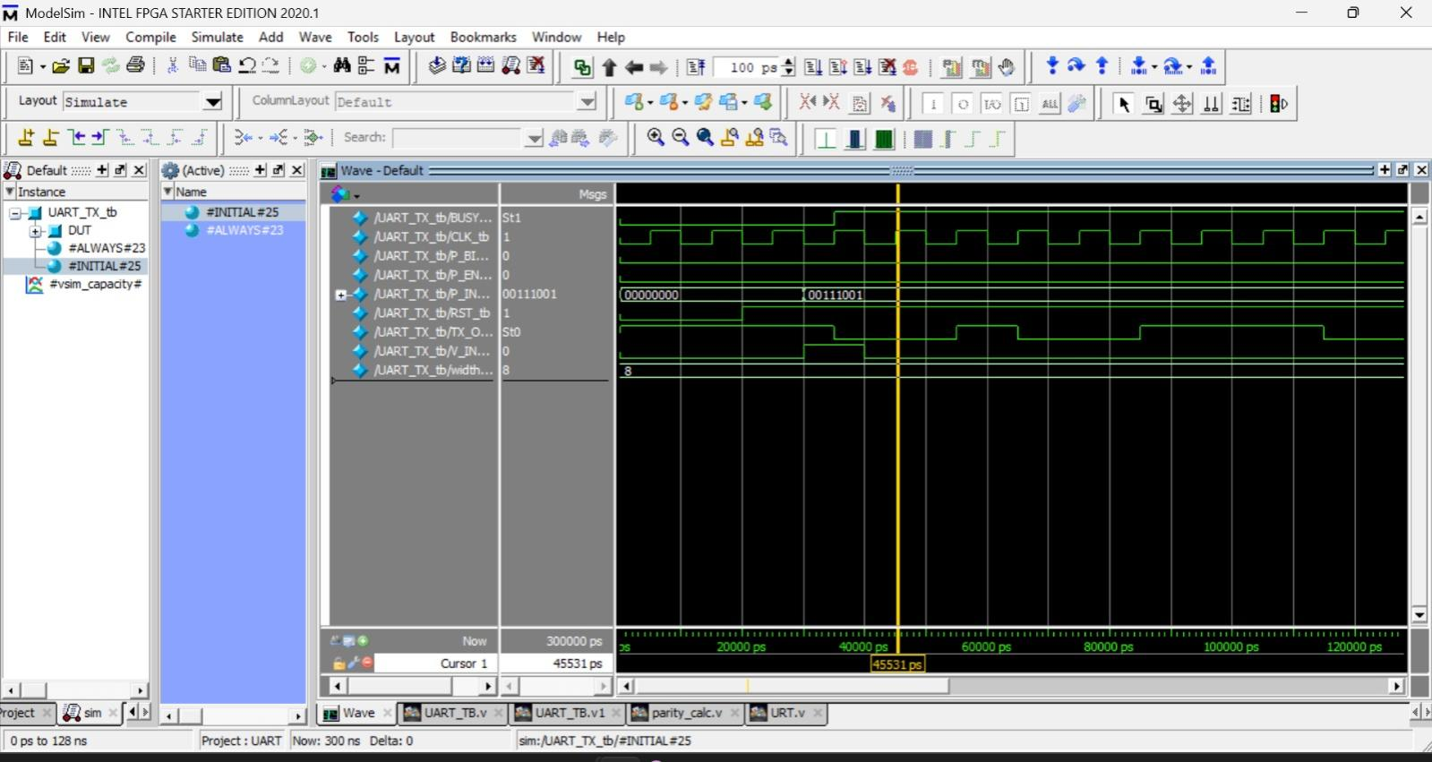
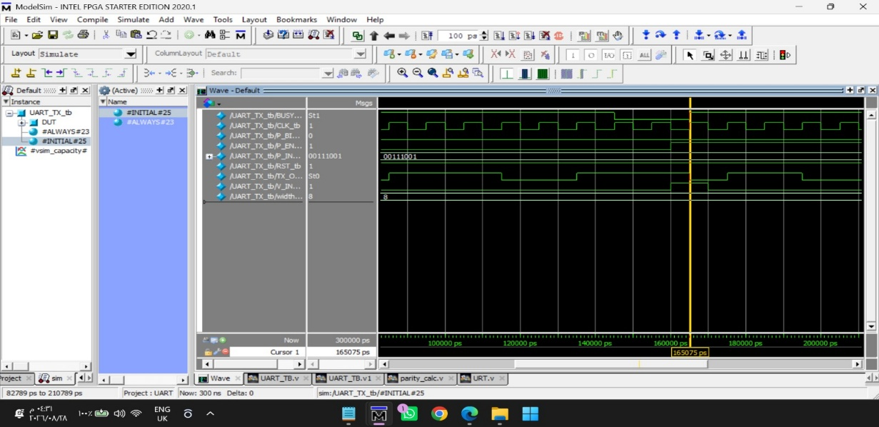
Second Frame Transmission (With Parity Enabled): After the first frame finishes, BUSY drops to 0 following the Stop bit. Then V_INPUT goes High (1) again to initiate a new frame with parity enabled. On the waveform, the Start bit is driven to 0 cleanly, whereas the transcript script logs it as 1 (FAIL).

Phase 2: Standalone Sub-Module Verification (Unit Testing)
To confirm whether the Start bit transcript failure originated from sub-module RTL logic or top-level control integration, testing was paused at the top level to run standalone unit testbenches for both core sub-modules.
Standalone Serializer Unit Verification (serializer_tb)
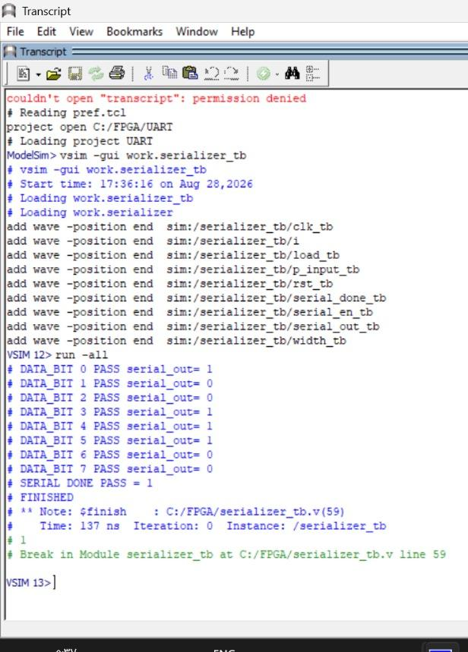
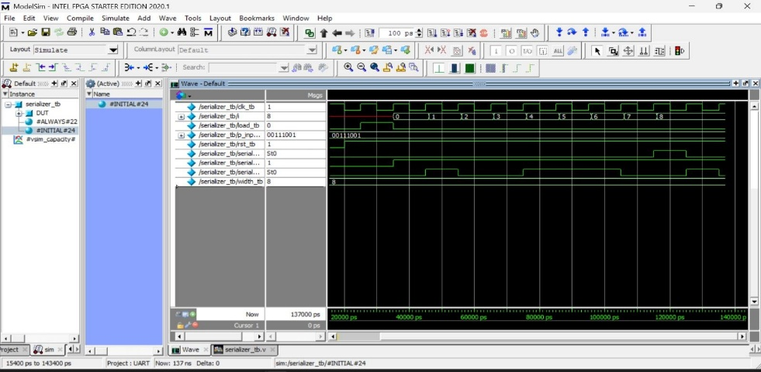
Implementation: Built a dedicated testbench applying an 8-bit parallel vector P_INPUT, triggering load, and monitoring ser_data_out and ser_done.Result: All unit test cases passed. Data shifted out LSB-first in synchronization with posedge CLK, and ser_done asserted cleanly without errors.

Standalone FSM Unit Verification (fsm_tb)
Implementation: Constructed a standalone testbench driving V_INPUT, P_EN, and ser_done across all states (IDLE, START, SER_DATA, PARITY, STOP).
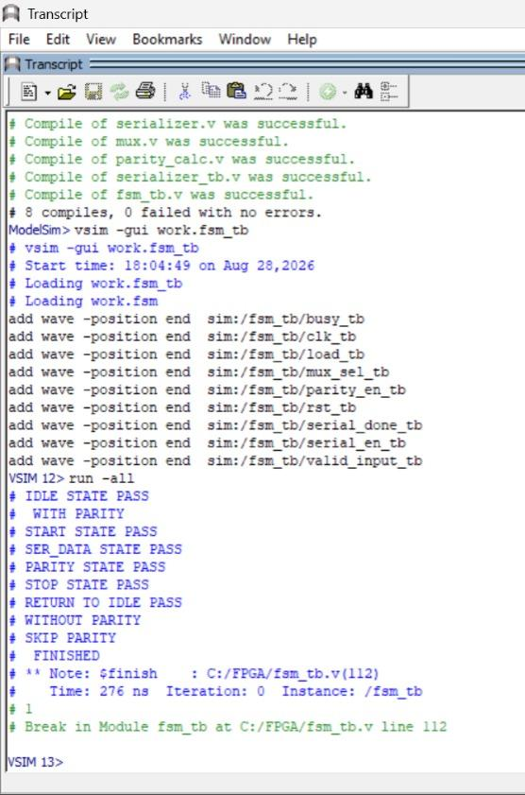
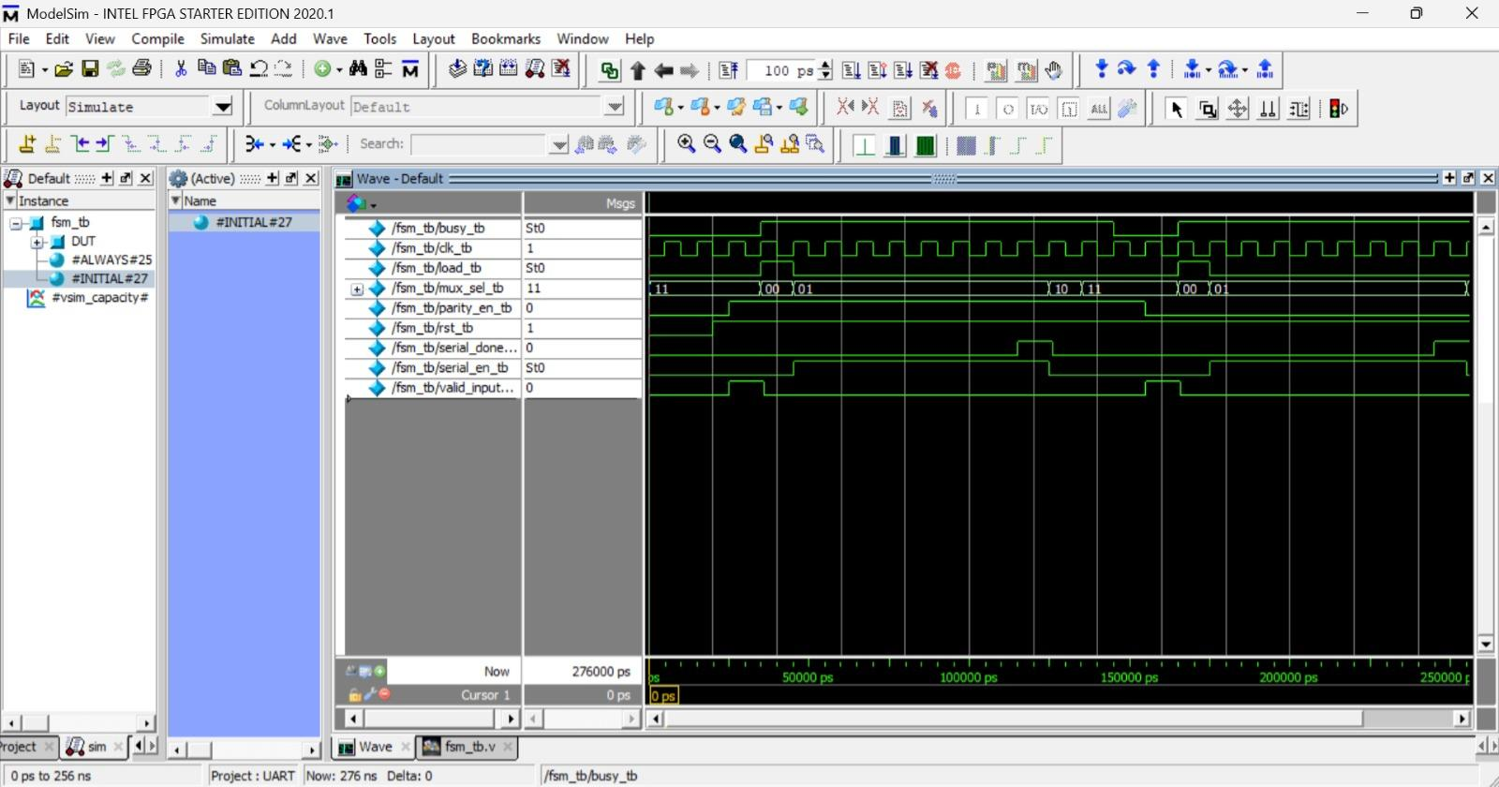
Result: All unit test cases passed. State transitions, BUSY flag control, and mux_sel routing signals operated as specified.

Phase 3: Top-Level Debugging and Delay Control Iterations
With standalone unit tests passing for both the FSM and Serializer, multiple debugging attempts were executed on the top-level testbench (UART_TB.v) to resolve the Start bit transcript mismatch.

Attempt 1: Modifying Delay Control (#10 to #15)
Action: Changed sampling assertion delay from #10 to #15 in the testbench.
Result: The Start bit remained FAIL. Payload data bits produced alternating pass and fail outcomes (some data bits passed while others failed).
Key Finding: Parity Bit and Stop Bit maintained PASS status.
Attempt 2: Clock Synchronization Before Start Bit Only
Action: Added posedge CLK synchronizer strictly before the Start bit assertion check.
Result:Start Bit: Changed to PASS.
Data Bits: Produced mixed results (DATA_BIT_0 PASS, DATA_BIT_1 FAIL, DATA_BIT_2 PASS, DATA_BIT_3 FAIL, DATA_BIT_4 PASS, DATA_BIT_5 PASS, DATA_BIT_6 FAIL, and DATA_BIT_7 PASS).
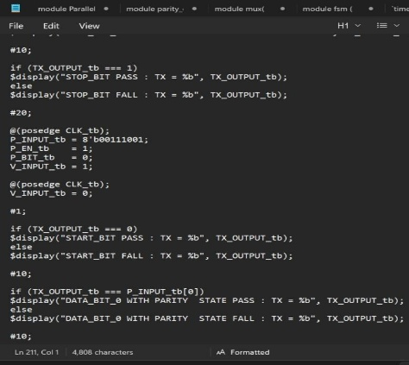
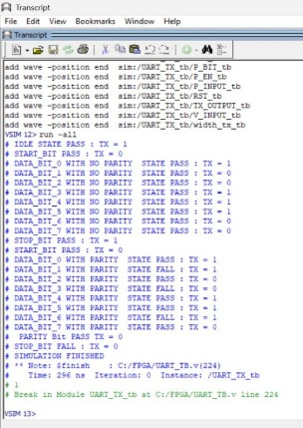
Parity and Stop Bits: Maintained PASS status.
Attempt 3: Clock Synchronization Across Data Bits (posedge CLK)
Action: Inserted posedge CLK synchronizers before checking every data bit condition (instead of checking only before the Start bit).
Result:Start Bit: Changed to PASS.
Data Bits: Produced mixed results (DATA_BIT_0 PASS, DATA_BIT_1 FAIL, DATA_BIT_2 PASS, DATA_BIT_3 FAIL, DATA_BIT_4 PASS, DATA_BIT_5 PASS, DATA_BIT_6 FAIL, and DATA_BIT_7 PASS).
Parity and Stop Bits: Maintained PASS status.
Key Observation: Applying posedge CLK synchronizers across all individual data bit conditions yielded the exact same outcome as Attempt 2, with no difference observed in the transcript output.

Attempt 4: BUSY and TX_OUT Signal Condition Checking (TX_OUTPUT == 1 && BUSY == 0)
Action: Added assertion logic to check the specific condition where TX_OUTPUT = 1 andBUSY == 0 to verify TX_OUTPUT driving during adle state.
Result: On the waveform, signals behaved correctly. However, in the transcript script, the Start bit still logged FAIL for the second frame (with parity enabled), while all payload data bits (DATA_BIT_0 through DATA_BIT_7), the Parity Bit, and the Stop Bit ,Idle state ,passed cleanly.
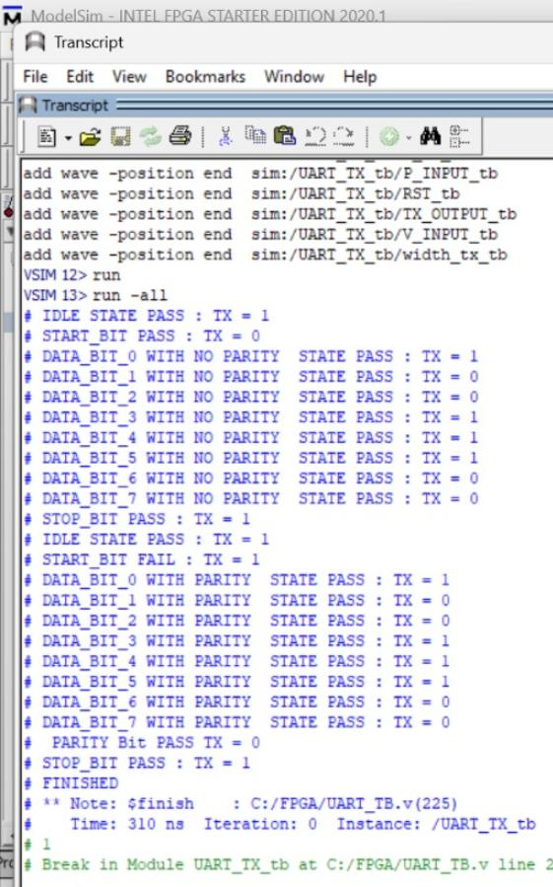
Final Decision
Because altering testbench sampling delays and clock edge alignment checks introduced artificial failures across data payload bits, the top-level testbench code was retained in its baseline state. In this baseline configuration, all payload data bits (0 through 7), parity calculations, and stop bits pass in the transcript, while the single Start bit failure for the second frame in the transcript remains an identified testbench strobe control issue under further refinement.

